**CICD EXPERIMENT-4**

Name: Aditya agarwal  
roll no: R171218007  
Sap id: 500069294

**STATIC CODE ANALYSIS USING SONARQUBE**

First download sonarqube

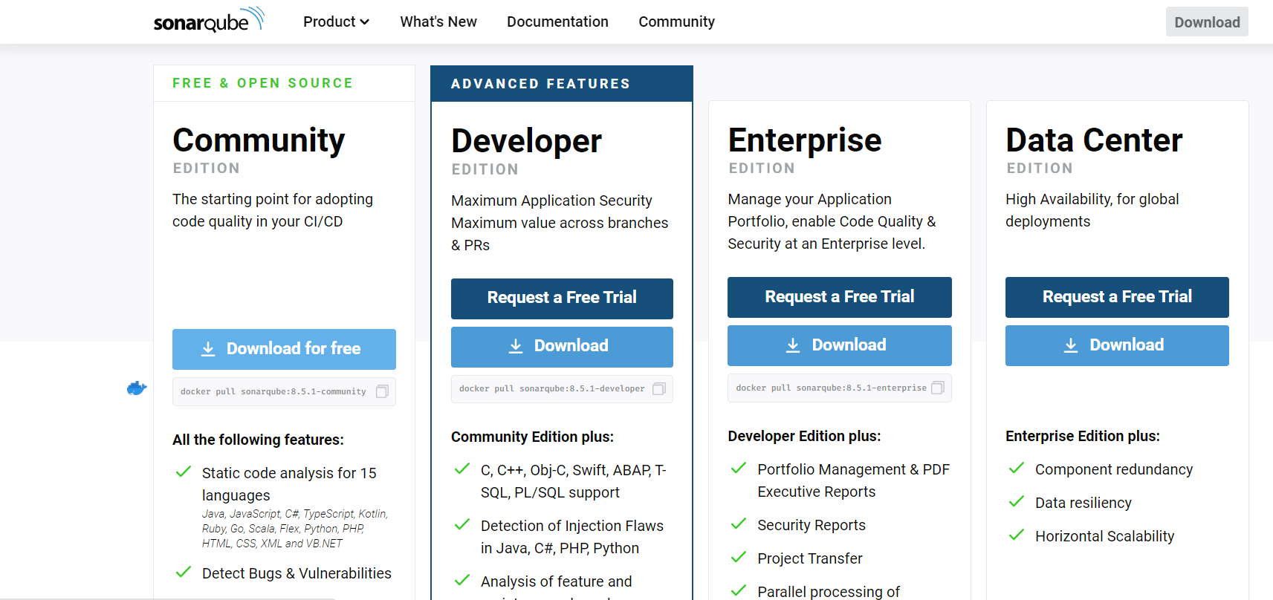

Then extract the bin and then copy the path of folder

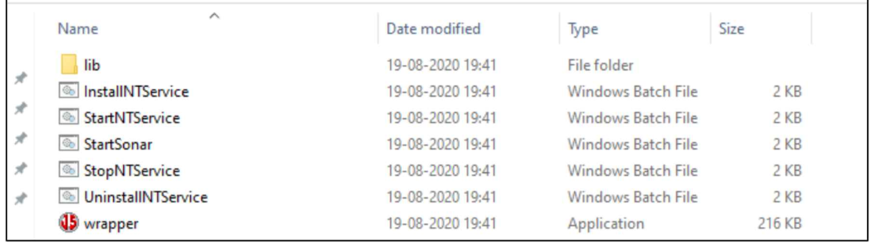

Type StartSonar.bat to start the sonarqube

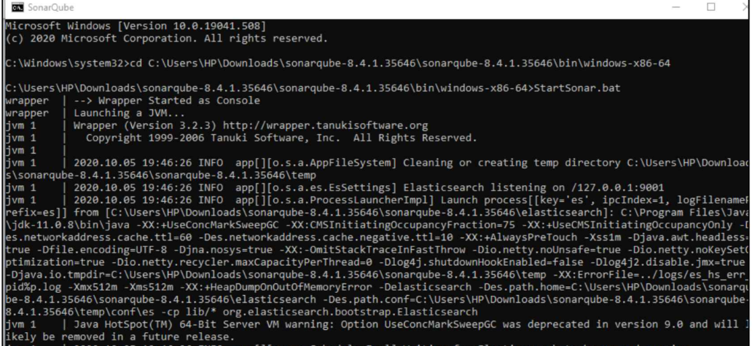

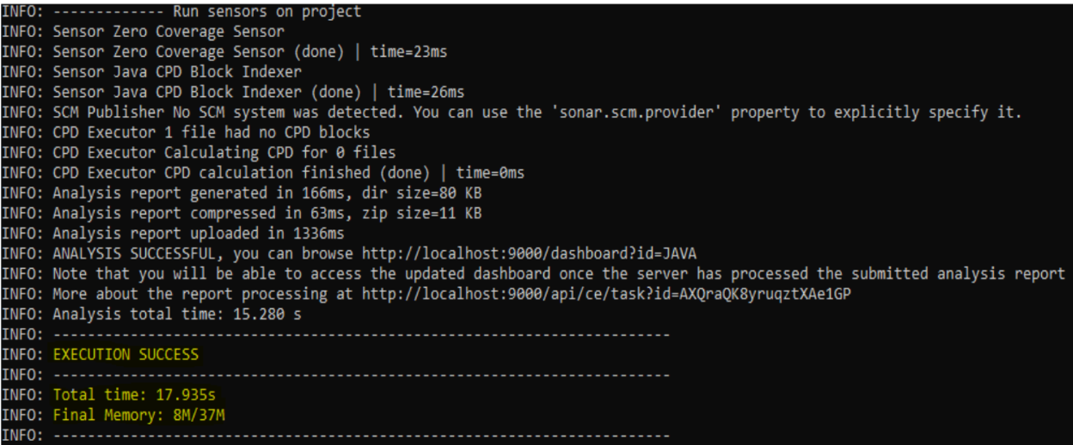

Change the directory to a mvn project

Run mvn clean install sonar:sonar – Dsonar.host.url=http://local host:9000 -Dsonar.analysis.mode=publish” in cmd

